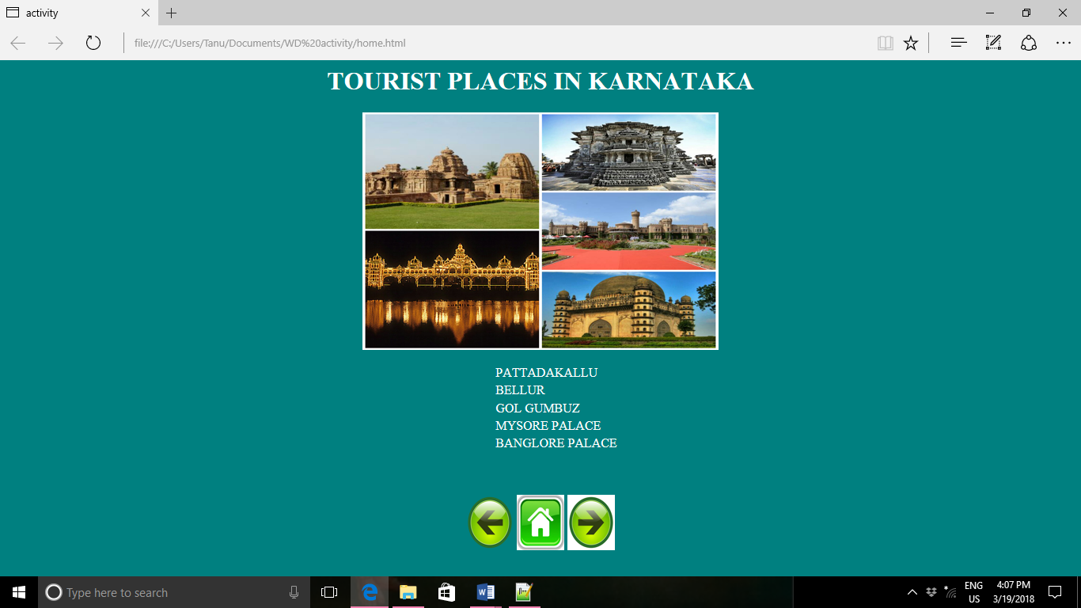

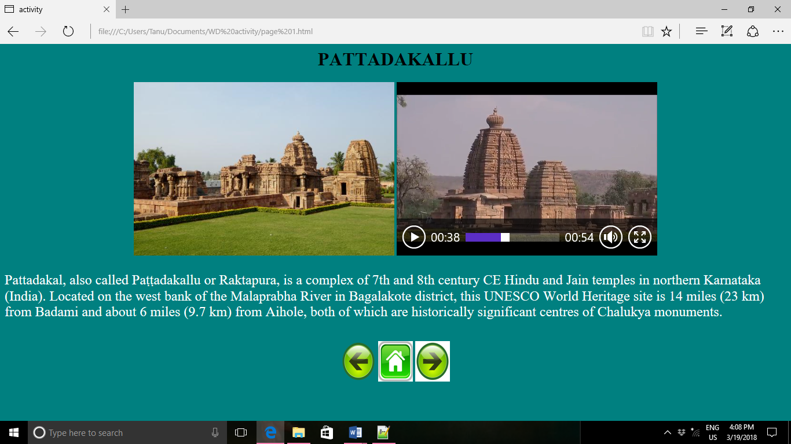

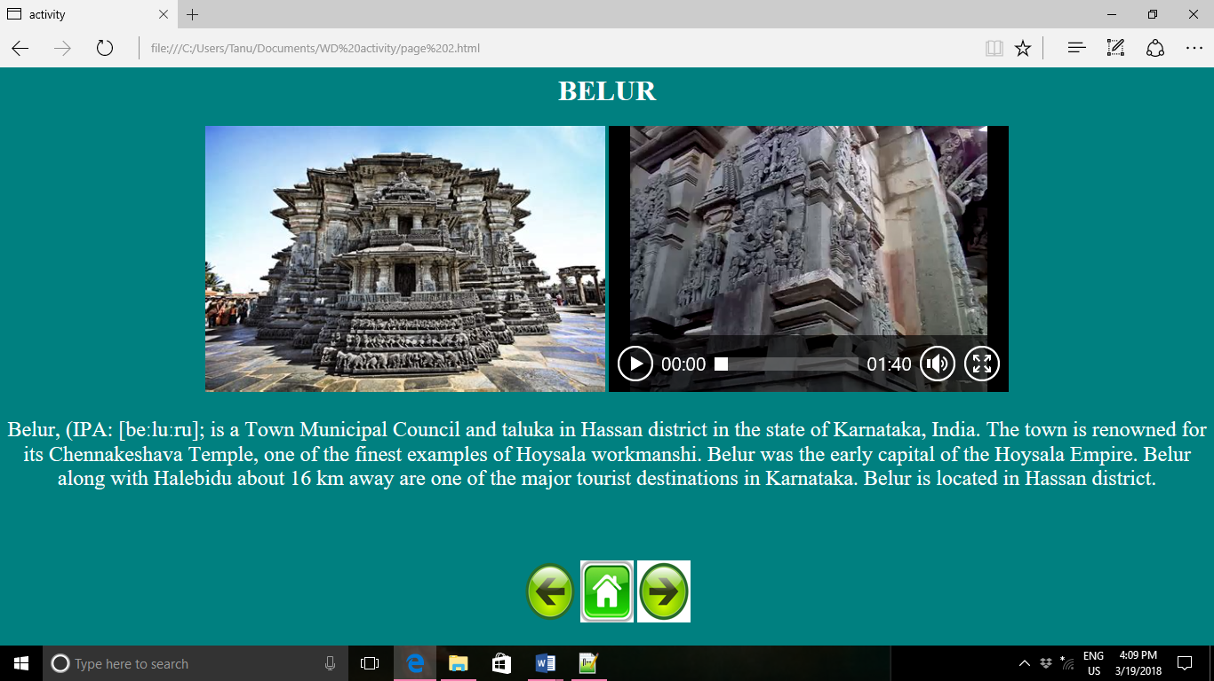

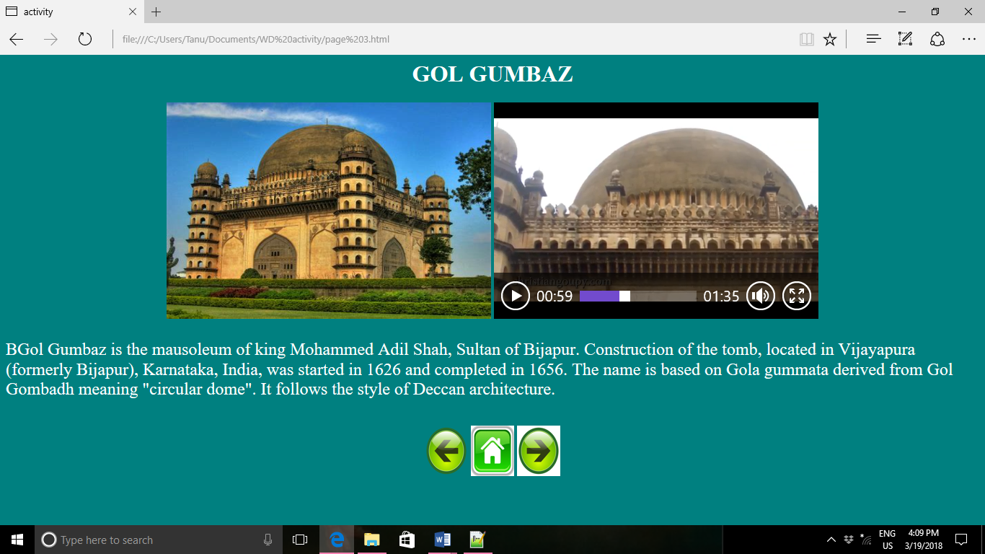

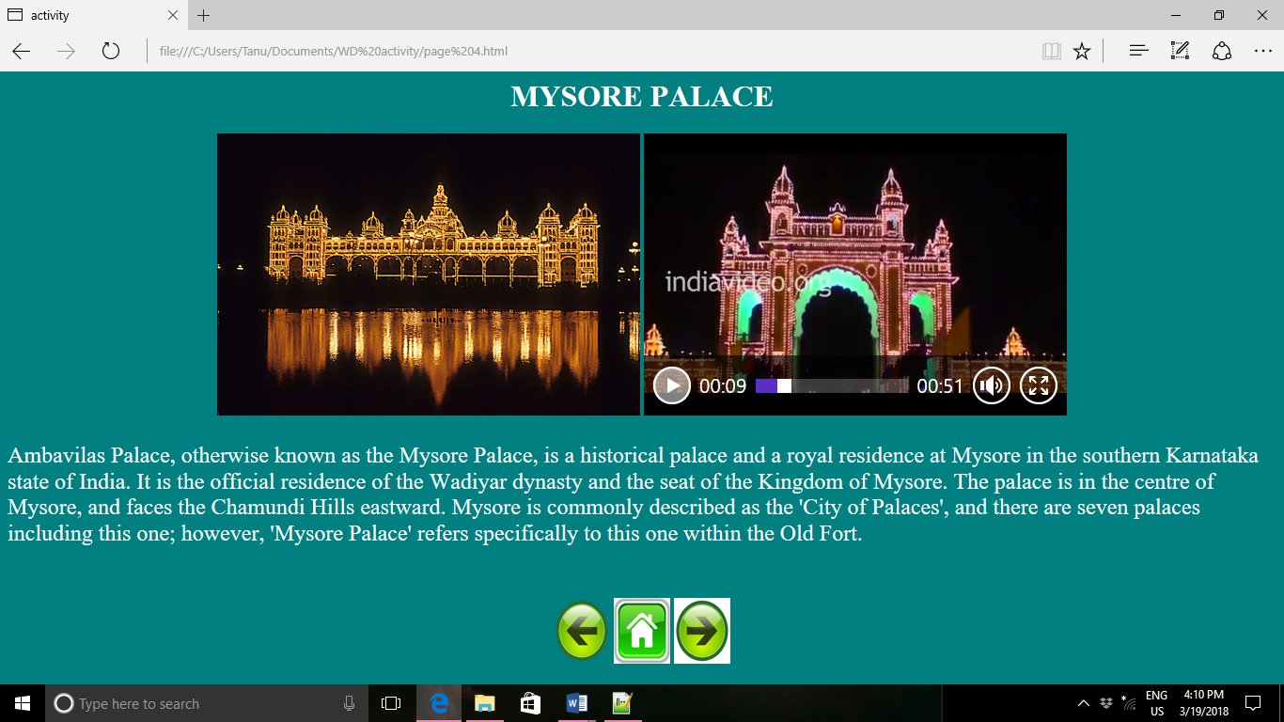

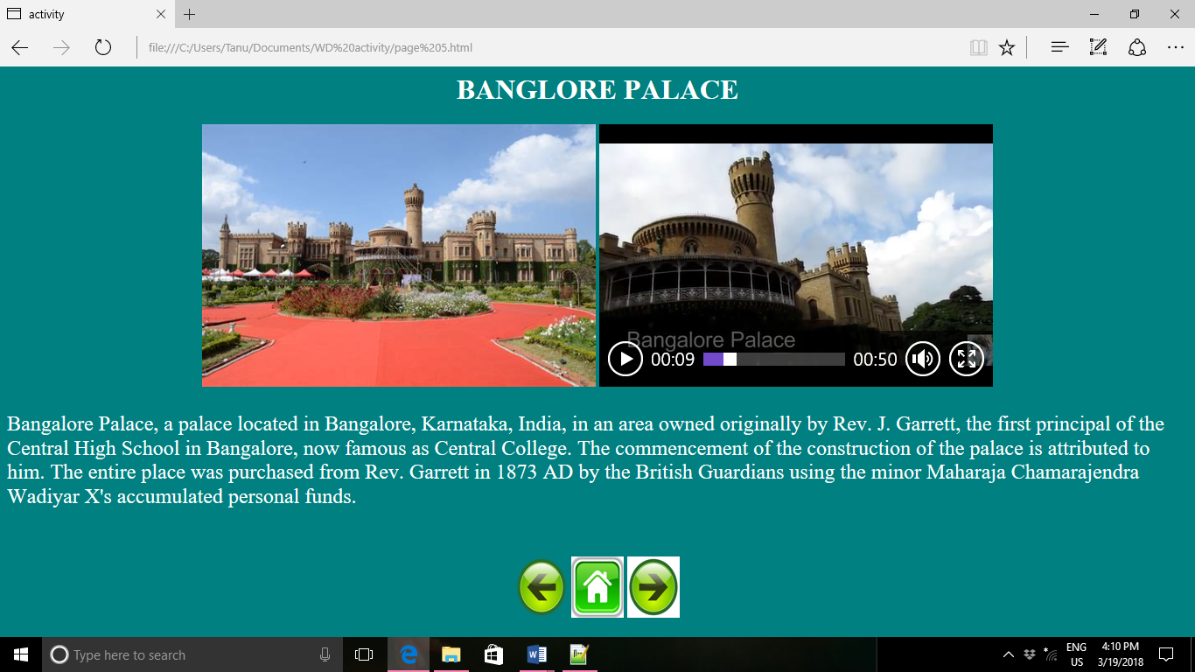

CODING
HOME PAGE.html
<html>
<head>
<title>activity</title>
</head>
<body bgcolor="teal">
<center>
<font color="white"><h1><b>TOURIST PLACES IN KARNATAKA</h1></b></font>
<img src="1520949052534.jpg" height="300" width="450">
<ol type="circle">
<font size="5" face="Times New Roman">
<table>
<tr>
<td>
<font color="white">PATTADAKALLU</font>
</td>
</tr>
<tr>
<td>
<font color="white">BELLUR</font>
</td>
</tr>
<tr>
<td>
<font color="white">GOL GUMBUZ</font>
</td>
</tr>
<tr>
<td>
<font color="white">MYSORE PALACE</font>
</td>
</tr>
<tr>
<td>
<font color="white">BANGLORE PALACE</font>
</td>
</tr>
</table>
</ol></font><br><br>

<img src="GreenButton_LeftArrow.svg.PNG" height="70" width="60">
<img src="thH08R752H.jpg" height="70" width="60">
<a href="page 1.html"><img src="th3G62NMA9.jpg" height="70" width="60"></a>
</center>
</body>
</html>

PAGE 1.html

<html>
<head>
<title>activity</title>
</head>
<body bgcolor="teal">
<center>
<h1><b>PATTADAKALLU</h1></b>
<img src="temple-de-pattadakal.jpg" height="300" width="450">
<video height="300" width="450"autoplay controls>
<source src="India_Karnataka__Pattadakal_Part_64.mp4" type="video/mp4">
</video>
</center>
<font size="5" face="Times New Roman">
<font color="white"><p>Pattadakal, also called Paṭṭadakallu or Raktapura, is a complex of 7th and 8th century CE Hindu and Jain temples in northern Karnataka (India). Located on the west bank of the Malaprabha River in Bagalakote district, this UNESCO World Heritage site is 14 miles (23 km) from Badami and about 6 miles (9.7 km) from Aihole, both of which are historically significant centres of Chalukya monuments.
</font>
</p></font><br><br>
<center>
<a href="home.html"><img src="GreenButton_LeftArrow.svg.PNG" height="70" width="60"></a>
<a href="home.html"><img src="thH08R752H.jpg" height="70" width="60"></a>
<a href="page 2.html"><img src="th3G62NMA9.jpg" height="70" width="60"></a>
</center>
</body>
</html>
PAGE 2.html
<html>
<head>
<title>activity</title>
</head>
<body bgcolor="teal">
<center>
<font color="white"><h1><b>BELUR</h1></b></font>

<img src="thFR9MNG32.jpg" height="300" width="450">
<video height="300" width="450" controls>
<source src="Chennakeshava_temple_at_Belur.mp4.mp4" type="video/mp4">
</video>
<font size="5" face="Times New Roman">
<font color="white"><p>Belur, (IPA: [beːluːru]; is a Town Municipal Council and taluka in Hassan district in the state of Karnataka, India. The town is renowned for its Chennakeshava Temple, one of the finest examples of Hoysala workmanshi.
Belur was the early capital of the Hoysala Empire. Belur along with Halebidu about 16 km away are one of the major tourist destinations in Karnataka. Belur is located in Hassan district.
</p></font><br><br></font>
<center>
<a href="page 1.html"><img src="GreenButton_LeftArrow.svg.PNG" height="70" width="60"></a>
<a href="home.html"><img src="thH08R752H.jpg" height="70" width="60"></a>
<a href="page 3.html"><img src="th3G62NMA9.jpg" height="70" width="60"></a>
</center>
</body>
</html>

PAGE 3.html
<html>
<head>
<title>activity</title>
</head>
<body bgcolor="teal">
<center>
<font color="white"><h1><b>GOL GUMBAZ</h1></b></font>
<img src="th96EC266A.jpg" height="300" width="450">
<video height="300" width="450"autoplay controls>
<source src="GOL_GUMBAZ.mp4" type="video/mp4">
</video>
</center>
<font size="5" face="Times New Roman">
<font color="white"><p>BGol Gumbaz is the mausoleum of king Mohammed Adil Shah, Sultan of Bijapur. Construction of the tomb, located in Vijayapura (formerly Bijapur), Karnataka, India, was started in 1626 and completed in 1656. The name is based on Gola gummata derived from Gol Gombadh meaning "circular dome". It follows the style of Deccan architecture.
</font>
</p></font><br><br>
<center>
<a href="page 2.html"><img src="GreenButton_LeftArrow.svg.PNG" height="70" width="60"></a>
<a href="home.html"><img src="thH08R752H.jpg" height="70" width="60"></a>
<a href="page 4.html"><img src="th3G62NMA9.jpg" height="70" width="60"></a>
</center>
</body>
</html>

PAGE 4.html
<html>
<head>
<title>activity</title>
</head>
<body bgcolor="teal">
<center>
<font color="white"><h1><b>MYSORE PALACE</h1></b></font>
<img src="mysore_palace-_illuminated.jpg" height="300" width="450">
<video height="300" width="450"autoplay controls>
<source src="Mysore_Palace,_Karnataka.mp4" type="video/mp4">
</video>
</center>
<font size="5" face="Times New Roman">
<font color="white"><p>Ambavilas Palace, otherwise known as the Mysore Palace, is a historical palace and a royal residence at Mysore in the southern Karnataka state of India. It is the official residence of the Wadiyar dynasty and the seat of the Kingdom of Mysore. The palace is in the centre of Mysore, and faces the Chamundi Hills eastward. Mysore is commonly described as the 'City of Palaces', and there are seven palaces including this one; however, 'Mysore Palace' refers specifically to this one within the Old Fort.
</p></font><br><br></font>
<center>
<a href="page 3.html"><img src="GreenButton_LeftArrow.svg.PNG" height="70" width="60"></a>
<a href="home.html"><img src="thH08R752H.jpg" height="70" width="60"></a>
<a href="page 5.html"><img src="th3G62NMA9.jpg" height="70" width="60"></a>
</center>
</body>
</html>

PAGE 5.html
<html>
<head>
<title>activity</title>
</head>
<body bgcolor="teal">
<center>
<font color="white"><h1><b>BANGLORE PALACE</h1></b></font>
<img src="thIN9OQOE0.jpg" height="300" width="450">
<video height="300" width="450"autoplay controls>
<source src="Bangalore_Palace_in_Karnataka_HD_-_A_glimpse_of_Royal_Seat_of_Wodeyar_Rulers.mp4" type="video/mp4">
</video>
</center>
<font size="5" face="Times New Roman">
<font color="white"><p>Bangalore Palace, a palace located in Bangalore, Karnataka, India, in an area owned originally by Rev. J. Garrett, the first principal of the Central High School in Bangalore, now famous as Central College. The commencement of the construction of the palace is attributed to him.
The entire place was purchased from Rev. Garrett in 1873 AD by the British Guardians using the minor Maharaja Chamarajendra Wadiyar X's accumulated personal funds.
</p></font><br><br></font>ss
<center>
<a href="page 4.html"><img src="GreenButton_LeftArrow.svg.PNG" height="70" width="60"></a>
<a href="home.html"><img src="thH08R752H.jpg" height="70" width="60"></a>
<a href="page 6.html"><img src="th3G62NMA9.jpg" height="70" width="60"></a>
</center>
</body>
</html>
PAGE 6.html
<html>
<head>
<title>activity</title>
</head>
<body bgcolor="teal">
<center>
<font size="5" face="Times New Roman"><font color="white"><h1>SUBMITTED BY</h1>
<p align="center"> 305CS17055 VAISHNAVI K <br>
<p align="center"> 305CS17056 VEENA K <br>
<p align="center"> 305CS17055 TEJUSHREE B M <br>
<p align="center"> 305CS17055 SHIVANGI DASGUPTA</font> <br><br><br></font>
<font color="white"><font size="5" face="Times New Roman">
<p align="center"> GUIDED BY<br>
</font>
<h2>S V HIREMATH</font>
</center><br><br><br>
<center>
<a href="page 5.html"><img src="GreenButton_LeftArrow.svg.PNG" height="70" width="60"></a>
<a href="home.html"><img src="thH08R752H.jpg" height="70" width="60"></a>
<img src="th3G62NMA9.jpg" height="70" width="60"></a>
</center>
</body>
</html>

